**Create a VPC**

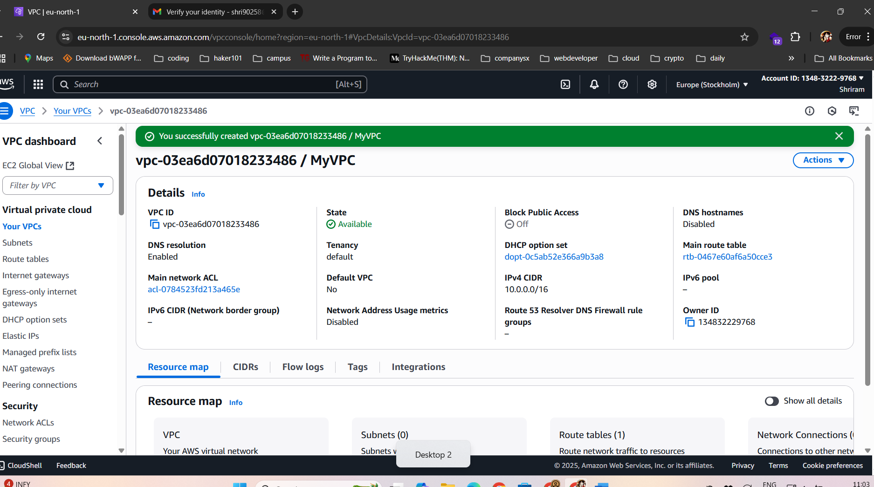

**Create an Internet Gateway**

**Create Subnets**

**Create Route Table**

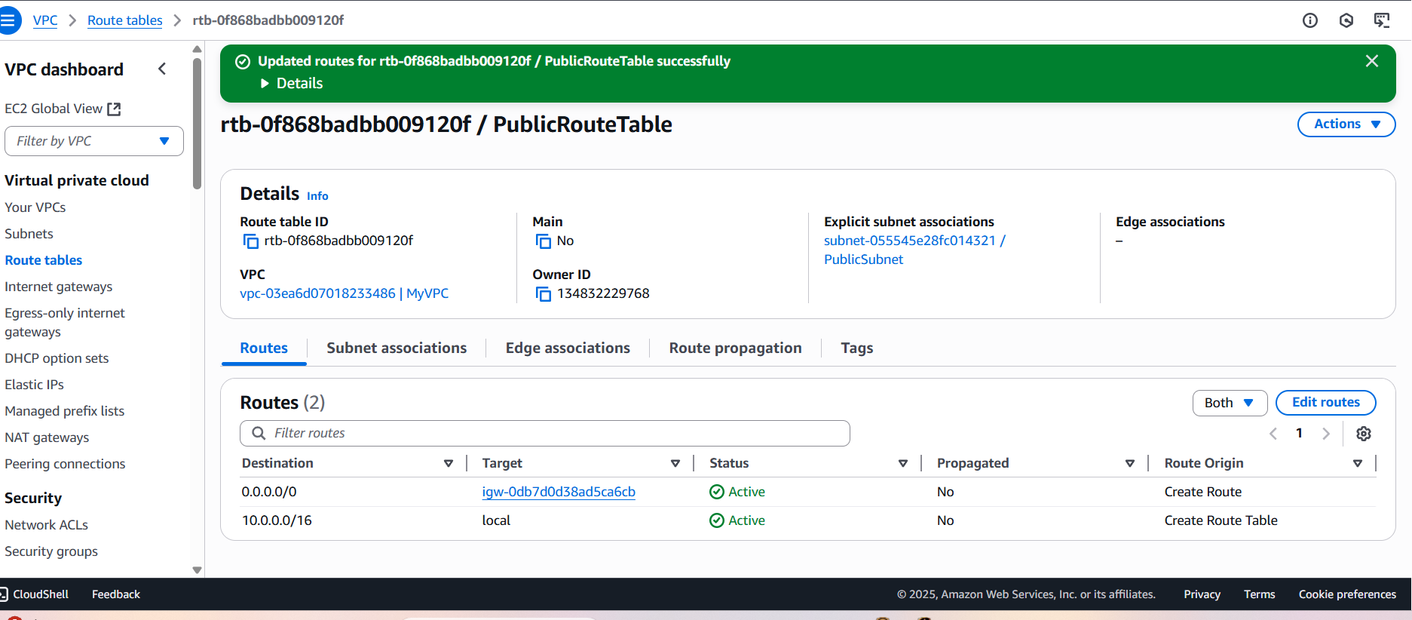

**Launch Linux EC2 Instance in Public Subnet**

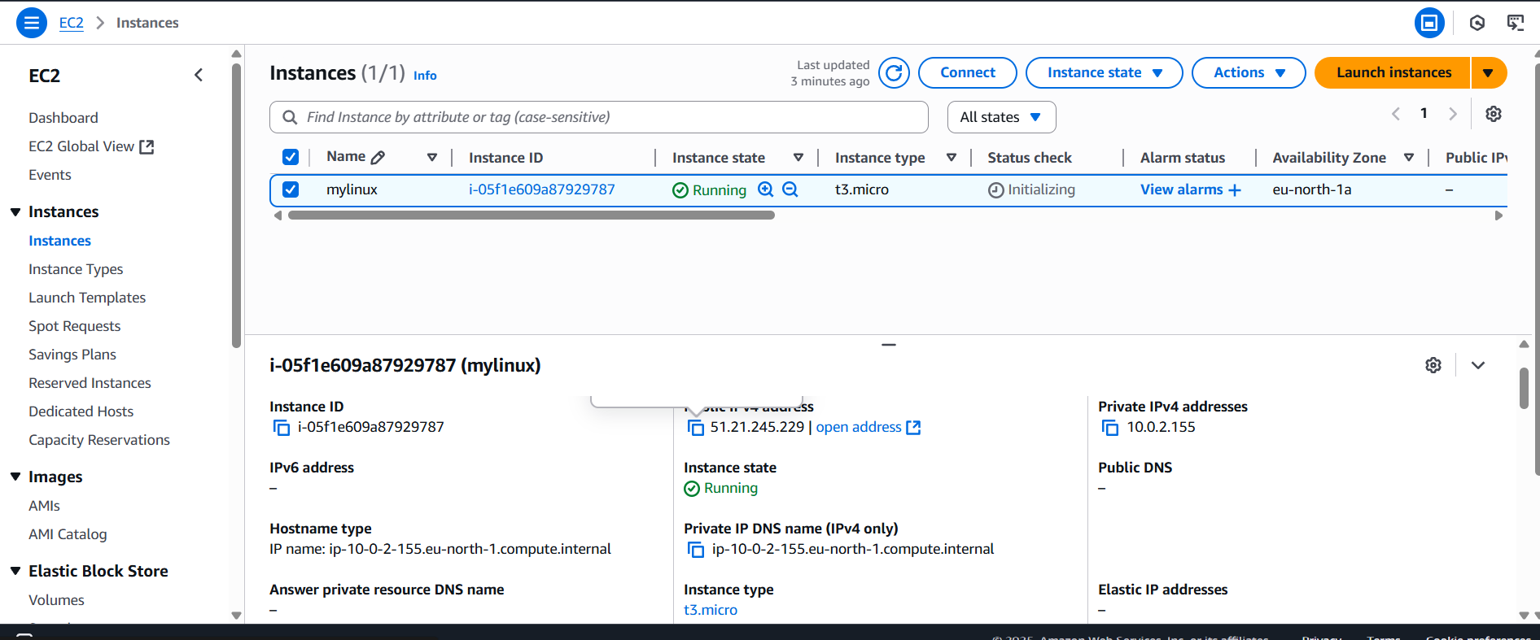

**GOT THE AMI IMAGE**

